Running the service

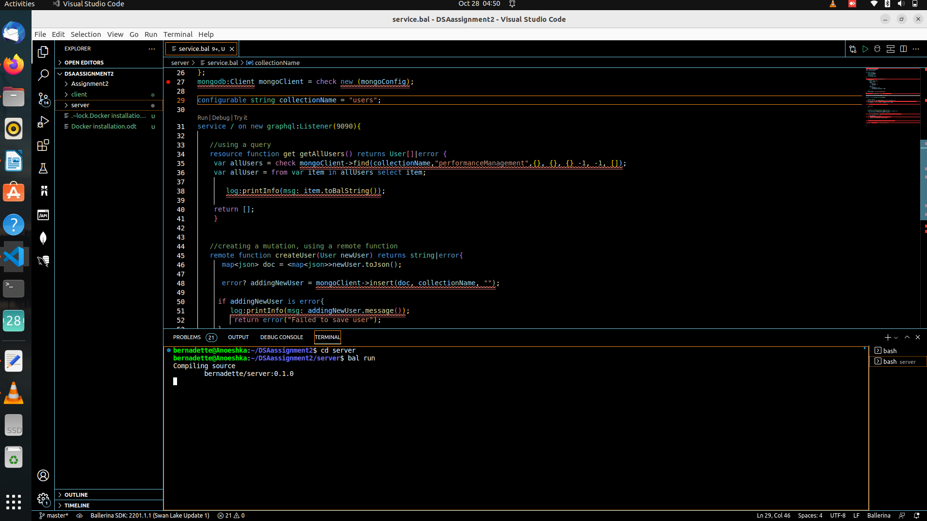
bksjnfdn

Server code

import ballerinax/mongodb;
import ballerina/graphql;
import ballerina/log;

type User record{
string firstname;
string lastname;
string id;
string department;
};

mongodb:ConnectionConfig mongoConfig = {
connection: {
host: "localhost",
port: 27017,
auth: {
username: "",
password: ""
},
options: {
sslEnabled: false,
serverSelectionTimeout: 5000
}
},
databaseName: "performanceManagement"
};

mongodb:Client mongoClient = check new (mongoConfig);

configurable string collectionName = "users";

@graphql:ServiceConfig {
graphiql: {
enabled: true
}
}

service / on new graphql:Listener(9090){
//using a query
resource function get getAllUsers() returns string{
var allUsers = check mongoClient->find(collectionName, "performanceManagement", {}, {}, {}, -1, -1, []);
log:printInfo(allUsers.toBalString());

return "hello world";
}

//creating a mutation, using a remote function
remote function createUser(User newUser) returns string|error{
map<json> doc = <map<json>>newUser.toJson();

error? addingNewUser = mongoClient->insert(doc, collectionName, "");
if addingNewUser is error{
log:printInfo(msg: addingNewUser.message());
return error("Failed to save user");
}

log:printInfo(msg: newUser.firstname + "saved successfully");

return newUser.firstname + "saved succesfully";
}

}

